Objective: Identify, simulate, and mitigate potential security weaknesses to ensure the system is cheat-proof and reliable.
Red Team Test Plan:
- Test Plan Overview.
- Scope : QR-based check-in, device binding, IP subnet validation, attendance cutoff, manual overrides, flagging engine, and audit logging.
- Goal: Ensure the system prevents fraud, unauthorized access, and misuse, while logging all suspicious activity.
- Threat Scenarios and Test Cases:

# | Threat / Attack Scenario | Test Steps | Expected System Response | Status / Notes
1 | Duplicate QR Scan | Attempt to scan the same QR multiple times using the same device or multiple devices | Only the first scan accepted; duplicates rejected and flagged
2 | Device Spoofing | Try to mark attendance using a device not registered to the student | System rejects the check-in and logs the attempt
3 | Unauthorized Network Access | Attempt check-in from Wi-Fi or IP outside the approved campus subnet | Attendance rejected; suspicious activity flagged
4 | Attendance After Cutoff | Submit attendance after the allowed time window | System auto-marks absent and logs late attempt
5 | Manual Override Abuse | Teacher/admin manually changes records without reason | System logs all changes with user, timestamp, and reason; missing reasons flagged
6 | QR Replay Attack | Capture QR and try to reuse it on a different device/session | Rejected if duplicate or invalid session; flagged
7 | Shared Account / Credential Abuse | Student tries to log in using another student’s credentials | Login denied if multi-factor / device binding active; attempt logged
8 | Multiple Accounts on One Device | Attempt to check in multiple students using one device | System flags suspicious device usage and rejects duplicate check-ins
9 | Tampering with API or Backend Calls | Try to submit attendance via modified API requests | Server-side validation rejects invalid data; logged for review
10 | Logging / Audit Evasion Attempt | Attempt to bypass logging or hide actions | All actions recorded server-side; tampering prevented

3. Testing Methodology
- Simulated Attacks: Each scenario is executed in a controlled environment to prevent real student data corruption.
- Observation: Monitor system logs, dashboards, and flags for correct detection.
- Documentation: Record test outcomes, including success, failure, or partial mitigation.
- Mitigation Validation: Confirm that fixes or controls correctly prevent the simulated attack.
- Re-testing: Re-run tests after any system changes to ensure persistent security.
4. Expected Outcomes
- All unauthorized or abnormal attendance attempts are rejected and logged.
- The system automatically flags suspicious activity on teacher dashboards.
- Manual overrides are auditable and accountable.
- Data integrity is maintained under all tested scenarios.
- The system demonstrates resilience against common student-based fraud and attacks.
5. Reporting & Recommendations
- Summarize findings in a Red Team Report: vulnerabilities, exploited weaknesses, and recommended mitigations.
- Provide clear steps for developers to implement fixes.
- Validate effectiveness of fixes through retesting.
Security Policies and their Purpose
These policies ensure that the attendance system is secure, cheat-proof, auditable, and reliable, while guiding the role of Security Analyst & Red Team Lead.
- Access Control Policy
Policy:
- Role-based access for Students, Teachers, and Admins.
- Principle of least privilege: users can only access features necessary for their role.
- Secure authentication mechanisms for all users.
How it Helps:
- Prevents students from accessing admin or teacher functionality.
- Limits potential damage from compromised accounts.
- Ensures only authorized users can mark attendance or perform overrides, reducing fraud.
- Attendance Data Policy
Policy:
- Attendance records are stored in a secure database (source of truth), not directly in Excel.
- All changes are logged, including timestamps, user, and reason.
- Access to attendance data is restricted to authorized roles.
How it Helps:
- Protects the integrity of attendance records from tampering.
- Ensures transparency and accountability for all changes.
- Maintains privacy by limiting access to sensitive data.
- Device & Network Policy
Policy:
- Each student account must be linked to one registered device only.
- Attendance submissions are allowed only when connected to the school’s approved Wi-Fi network.
- Device sharing between students is strictly prohibited.
How it Helps:
- Prevents students from marking attendance using another student’s device.
- Ensures attendance reflects actual physical presence on campus.
- Reduces risk of spoofing or remote check-ins.
- Helps the system accurately detect and flag suspicious activity if multiple accounts attempt to use the same device or network.
- QR Code Policy
Policy:
- Static QR codes are assigned per venue.
- QR codes cannot be copied, shared, or reused outside the allowed session.
- QR codes are valid only during the allowed attendance window.
How it Helps:
- Prevents students from using QR codes to mark attendance fraudulently.
- Enforces session-specific timing so only valid check-ins are accepted.
- Simplifies attendance tracking while maintaining security.
- Audit & Logging Policy
Policy:
- All actions—manual overrides, failed attempts, and suspicious activity—are logged.
- Logs are tamper-proof and regularly reviewed by authorized personnel.
How it Helps:
- Creates accountability for teachers, admins, and students.
- Detects and investigates suspicious behavior or attempted fraud.
- Supports compliance with institutional and legal auditing requirements.
- Fraud Prevention Policy
Policy:
- Duplicate submissions are blocked.
- Attendance submissions from unregistered devices or off-campus networks are rejected and flagged.
- Only one device per student is allowed.
- Rule-based enforcement for timing, network, and device constraints.
How it Helps:
- Stops students from marking attendance multiple times or from unauthorized devices.
- Alerts teachers to unusual activity before it becomes an issue.
- Maintains system integrity without requiring manual monitoring.
- Manual Override Policy
Policy:
- Only authorized teachers or admins can perform overrides.
- A reason must be provided for all manual changes.
- All overrides are logged in the audit system.
How it Helps:
- Ensures overrides are justified and accountable.
- Prevents unauthorized manipulation of attendance records.
- Maintains a clear audit trail for compliance and review.
- Red Team Testing Policy
Policy:
- Simulated attacks are conducted in a controlled environment.
- Real student data cannot be corrupted.
- All findings, including vulnerabilities and attempted exploits, are documented and shared with developers.
How it Helps:
- Identifies weaknesses before students or attackers can exploit them.
- Ensures security controls are working as intended.
- Provides actionable insights for system improvements.
- Security Review Policy
Policy:
- Logs, flagged activity, and Red Team findings are reviewed regularly.
- Security rules and controls are updated as needed.
- Continuous monitoring ensures the system adapts to evolving threats.
How it Helps:
- Keeps the system resilient against new attack techniques.
- Detects and prevents emerging fraudulent behaviours.
- Supports ongoing improvement of security and reliability.
Summary:
These policies collectively ensure the attendance system is:
- Accurate – only valid students can mark attendance
- Secure – prevents unauthorized access and fraudulent activity
- Auditable – all actions are traceable and transparent
- Reliable – system functions automatically without daily intervention
- Maintainable – security is proactive, not reactive

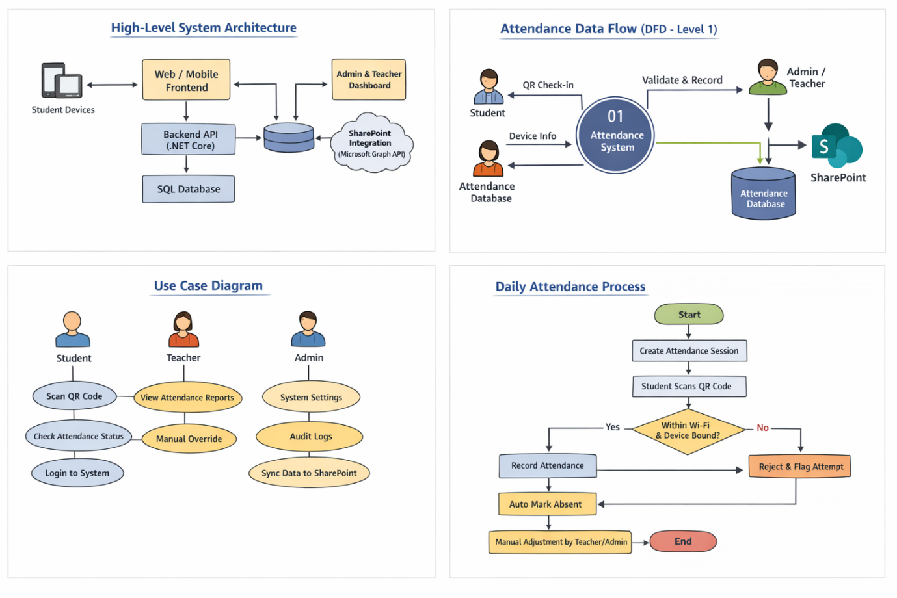

Terms and Conditions of Use
The following Terms and Conditions govern the use of the Digital Attendance System. By accessing or using the system, all users agree to comply with these terms.
1. User Responsibility
- Users must provide accurate and truthful information at all times.
- Login credentials are personal and must not be shared.
- Users are responsible for all actions performed under their account.
2. Device Usage
- Each student is permitted to register and use one device only for attendance purposes.
- The registered device must not be shared with other users.
- Any attempt to use multiple devices or another user’s device will be flagged as suspicious activity.
3. Network Access
- Attendance may only be marked when connected to the official school Wi-Fi network. (No mobile data usage may be permitted!)
- Attempts to mark attendance from off-campus or unauthorized networks will be rejected and logged.
4. Attendance Integrity
- Attendance must only be marked by students who are physically present at the venue.
- Any attempt to falsify attendance records is considered misconduct.
- The system automatically enforces attendance windows and cutoff times.
5. Prohibited Activities
Users may not:
- Attempt to bypass security controls
- Share QR codes for fraudulent attendance marking
- Manipulate attendance data
- Exploit system vulnerabilities
- Interfere with logging or audit mechanisms
6. Monitoring and Logging
- All system activities are monitored and logged for security and audit purposes.
- Suspicious behaviour may be reviewed by authorized staff.
- Logs may be used for investigations, reporting, and compliance.
7. Manual Overrides
- Manual attendance changes are restricted to authorized Teachers and Administrators.
- All overrides must include a valid reason and are permanently logged.
8. Disciplinary Action
- Violations of these Terms and Conditions may result in disciplinary action.
- Repeated or severe violations may lead to account suspension or further institutional action.
9. System Availability
- The institution does not guarantee uninterrupted system availability.
- Maintenance or technical issues may temporarily limit access.
10. Amendments
- These Terms and Conditions may be updated as system features evolve.
- Continued use of the system constitutes acceptance of updated terms.

Acceptance of Terms
☐By using the Digital Attendance System, users acknowledge that they have read, understood, and agreed to these Terms and Conditions.

